**DHAKA CITY COLLEGE**

**DEPARTMENT OF COMPUTER SCIENCE AND ENGINEERING (CSE)**

**Website: www.dhakacitycollege.edu.bd**

# PROJECT PROPOSAL

**============================**

**DATE: 30-Sep-20 >> Student 1**

|  |  |
| --- | --- |
| Name of the Student | Md Antor Ahmed |
| Section | B |
| Roll No. | 68 |
| Session | 2018 |
| Present Address | South Keranigonj |
| Mobile No (Student) | 01764180287 |
| NU Reg. No | 16502000527​ |

**>> Student 2**

|  |  |
| --- | --- |
| Name of the Student | Al Sabid |
| Section | B |
| Roll No. | 63 |
| Session | 2018 |
| Present Address | Kamrangirchar |
| Mobile No (Student) | 01521327693 |
| NU Reg. No | 16502000525​ |

|  |  |
| --- | --- |
| Name of the Supervisor | Md.Shahiduzzaman Torun​ |
| **Designation** | Assistant Professor |

​

|  |  |
| --- | --- |
| Name of the Guide Teacher | Shirin Nahar Sathi​ |
| **Designation** | Assistant Professor |

**Project Title (Block Letters):**

# IOT REAL WORLD PROGRAMMABLE BLOCKS

**Background and present state of the topic:**

The definition of the Internet of things (IoT) has evolved due to the convergence of multiple technologies, real-time analytics, machine learning, commodity sensors, and embedded systems. Nowadays there are many IoT devices available such as IoT light, IoT home, IoT industrial devices and more. But these devices are limited to use, we just control it over the internet and see statistical data nothing much more than. Some of them offer simple automation features like auto on/off timer etc. The weird thing about present IoT devices are all not in the same dashboard. That means we need to configure a lot for multiple devices. Let’s see an example, suppose we have an IoT light that can turn on and off from an App. Now we want to turn it off automatically when none in the room present. But unfortunately, our IoT light can’t do it. So, we need to set up an external device that sends a trigger to our device and force it to turn it off. Which is very complicated for most of the customers! So, we face difficulty here. We can’t apply our own logical expression on it.

**Objective with specific aims and possible outcome:**

**See the following picture is our proposal project:**

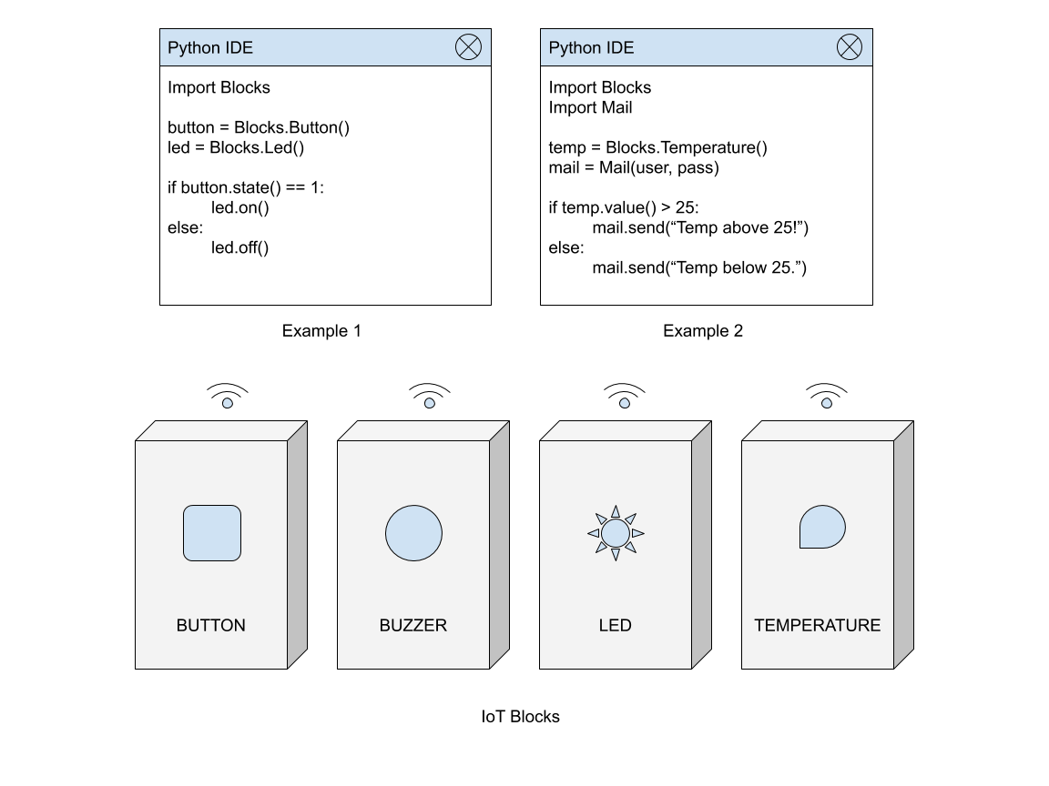

**>> Our IoT Blocks are divided into four parts:**

* Input device blocks (Buttons, Temperature, Motion etc.).
* Output device blocks (LED, Buzzer, GPIO etc.).
* Python programming API.
* Server-side backend API.

***The main objectives of this technology are:***

* Easily can integrate to any environment.
* Can apply any logical expression, iteration.
* Blocks can be used as single or combined together.
* Can be re-programmed on demand.
* No limitation of use.

***The possible outcomes of this technology are:***

* Smart home automation.
* Industrial IoT control.
* Increases productivity of daily life.
* Simplify large tasks into smaller.
* Security system for home and office.
* Teaching programming logics easily to high school students.

**Outline of Methodology / Experiment Design:**

* We use MySQL as a database.
* Programming languages like C++, Python, PHP are used generally.
* Arduino IDE for hardware level programming.
* Basic electronics knowledge.
* 3D modelling and printing.
* API development using lumens framework.

**References:**

1. [**https://en.wikipedia.org/wiki/Internet_of_things**](https://en.wikipedia.org/wiki/Internet_of_things)
2. [**https://fastapi.tiangolo.com/tutorial/**](https://fastapi.tiangolo.com/tutorial/)
3. [**https://www.arduino.cc/en/IoT/HomePage**](https://www.arduino.cc/en/IoT/HomePage)
4. [**https://en.wikipedia.org/wiki/Home_automation**](https://en.wikipedia.org/wiki/Home_automation)
5. [**http://docs.makeblock.com/codeyrocky/en/tutorials/iot.html**](http://docs.makeblock.com/codeyrocky/en/tutorials/iot.html)

**List of Courses so far taken with course no, name of the courses, credit hours, Grade, Grade Points and C.G.P.A. (To be verified and signed by the Guide Teacher):**

## Student Name: ​ Md Antor Ahmed

|  |  |  |  |  |
| --- | --- | --- | --- | --- |
| Course No | Credit  Hours | Grade | Grade  Points | C.G.P.A. |
| 1​st​ Semester |  |  |  |  |
| 2​nd​ Semester |  |  |  |
| 3​rd​ Semester |  |  |  |
| 4​th​ Semester |  |  |  |
| 5​th​ Semester |  |  |  |

**Student Name:** ​ **Al Sabid**

|  |  |  |  |  |
| --- | --- | --- | --- | --- |
| Course No | Credit  Hours | Grade | Grade  Points | C.G.P.A. |
| 1​st​ Semester |  |  |  |  |
| 2​nd​ Semester |  |  |  |
| 3​rd​ Semester |  |  |  |
| 4​th​ Semester |  |  |  |
| 5​th​ Semester |  |  |  |

**Signature and Name of the students:** ​

1. MD. Antor Ahmed​
2. Al Sabid​